Individual vs Team Commission Plans in Odoo 19: Which One Should Your Business Use?
Rohan Raj — Infintor Solutions | March 2026
You’ve decided to use Odoo 19’s Commissions module. The feature is enabled, the settings are saved, and you’re staring at the commission plan form. Then you see it — per Salesperson or per Sales Team. It seems like a simple dropdown, but choosing the wrong option here reshapes your entire incentive structure.
Most Indian businesses run both individual and team-based sales motions. A pharma distributor might have territory reps who close deals independently while also running a key accounts team where three people collaborate on large hospital orders. Picking the right plan type for each group is the difference between a commission structure that motivates and one that creates resentment.
This blog breaks down both options — how they work in Odoo 19, when to use each, and how to run them side by side. Everything here is verified on a live Odoo 19 instance.

Enabling Commissions in Odoo 19
Sales → Configuration → Settings → Invoicing → Enable Commissions → Save
This activates the sale_commission module and adds the Commissions menu to the Sales app:
- Commission Plans — create and manage plans
- Commissions — view all calculated commission data
- My Commissions — individual salesperson’s own commission view
A reporting entry also appears under Sales → Reporting → Commissions for management-level pivot and graph analysis.
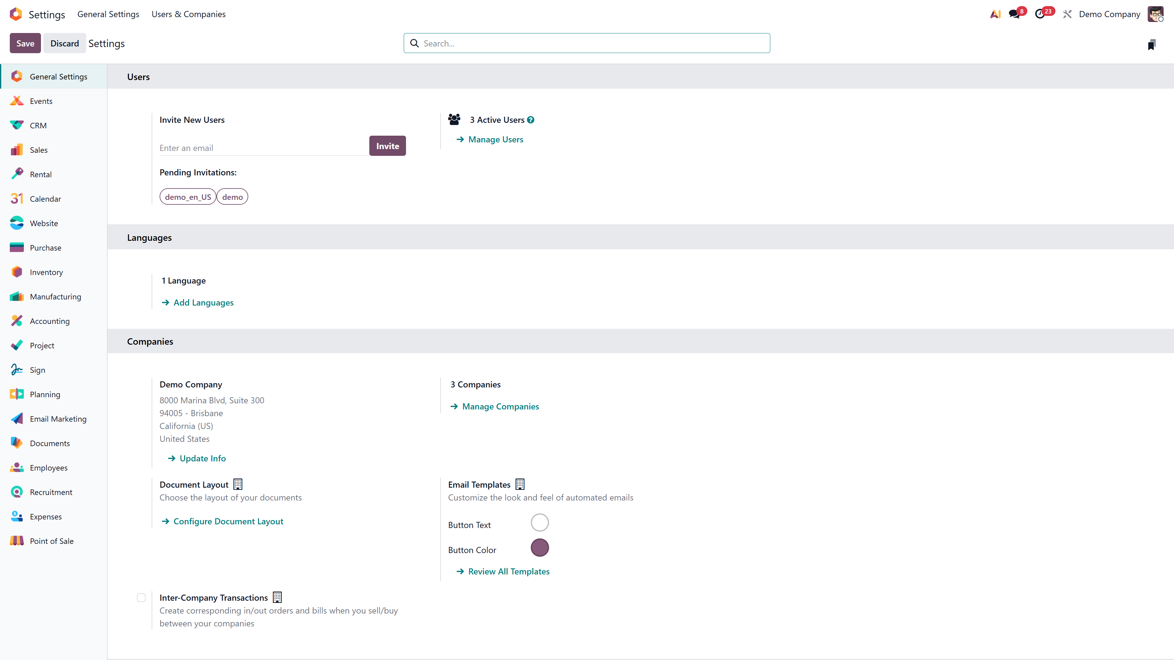
Sales Settings → Invoicing → Commissions enabled

The Two Assignment Models: Salesperson vs Sales Team
When creating a commission plan, the per field determines who gets evaluated:

Setting | What It Means
per Salesperson | Each assigned salesperson is tracked and paid individually
per Sales Team | The entire team is evaluated as a unit against a shared target or metric

Important: You cannot change this setting after the plan is approved. Choose deliberately.
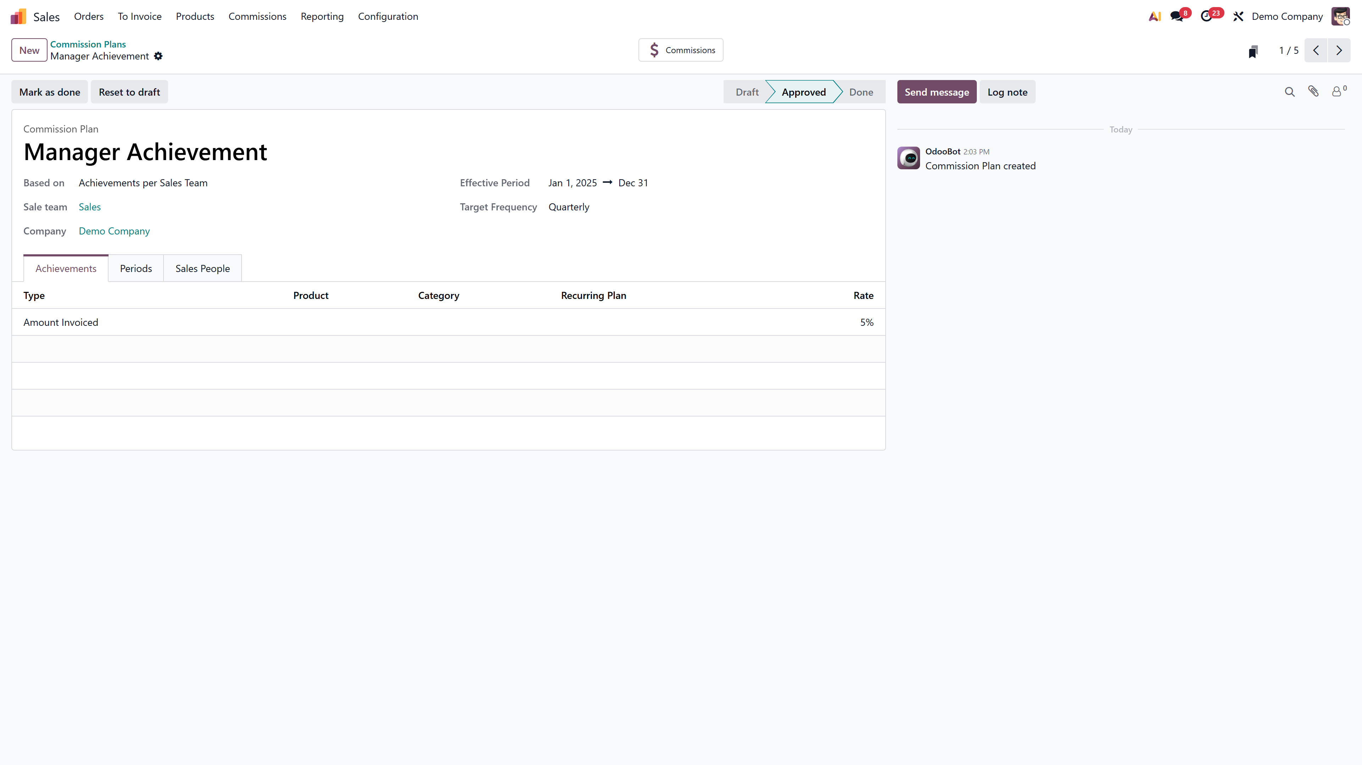
Commission plan form showing the “per” dropdown for Salesperson vs Sales Team

How Individual (Salesperson) Plans Work

Setup
- Create a new Commission Plan → set per to Salesperson
- Choose Targets or Achievements as the plan type
- Set the effective period and periodicity (monthly / quarterly / yearly)

Targets Tab (Target-Based Plans)
Odoo auto-generates target periods based on periodicity. Each period has:
- Target amount — what the salesperson should achieve (e.g., ₹5,00,000)
- Payment date — when commission is due
Every assigned salesperson is measured independently against these same targets.

Commission Levels
Tiers determine the payout at each achievement percentage:

% of Target | Commission Payout
0% | ₹0
50% | ₹10,000
100% | ₹30,000 (On Target Commission)
150% | ₹45,000
200% | ₹60,000

Odoo interpolates linearly between levels. A salesperson at 75% target earns ₹20,000 (midpoint between 50% and 100% levels).

Sales People Tab
Add individual salespeople here. Each gets:
- Salesperson name — links to an Odoo user
- Custom From/To dates — useful for mid-quarter hires
- Individual achievement tracking — their invoices/orders are measured independently
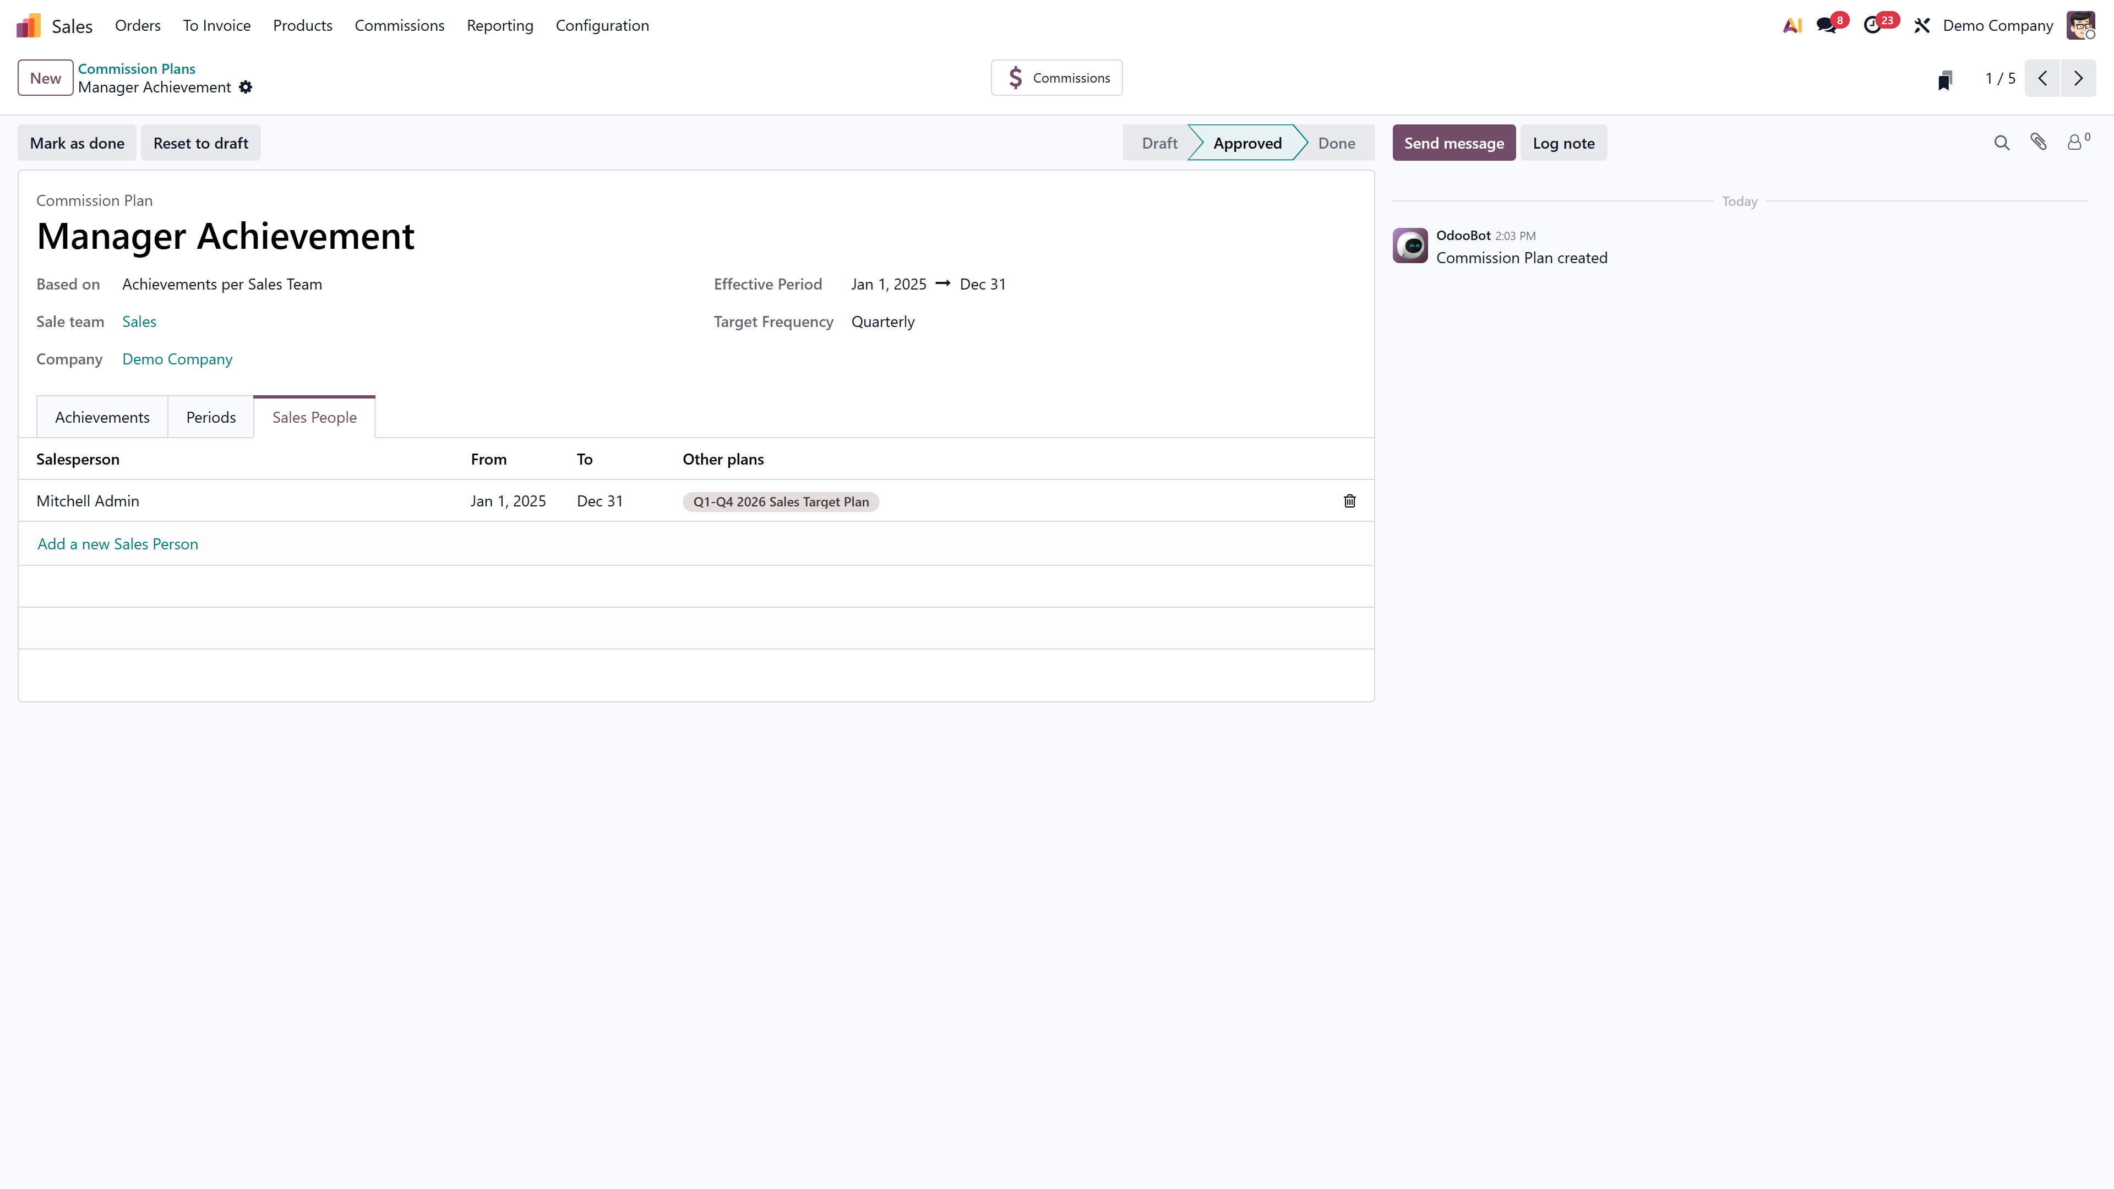
Sales People tab with assigned salespeople and date ranges

How Achievement Is Tracked
The Achievements tab defines what counts:
- Type: Amount Invoiced, Amount Sold, Quantity Invoiced, or Quantity Sold
- Rate: Multiplier (default 1.0)
- Category: Optional product category filter
When a salesperson confirms an invoice, Odoo automatically tallies it against their target for the active period.

How Team Plans Work

Setup
- Create a new Commission Plan → set per to Sales Team
- Select the Sales Team — this field becomes mandatory
- Choose Targets or Achievements, set period and periodicity

Key Difference: Shared Target
In a team plan, the target applies to the entire team, not individual members. If Q1 target is ₹20,00,000, the team succeeds or fails as a unit.

Sales People Tab in Team Plans
You still add salespeople to the plan, but their individual numbers contribute to the team total. The commission payout is determined by the team’s collective achievement, then distributed to each listed member.

When Team Plans Make Sense
- Collaborative selling — multiple people work the same deal
- Account management teams — relationship managers + technical pre-sales working together
- Branch-level incentives — an entire branch location hitting a revenue goal
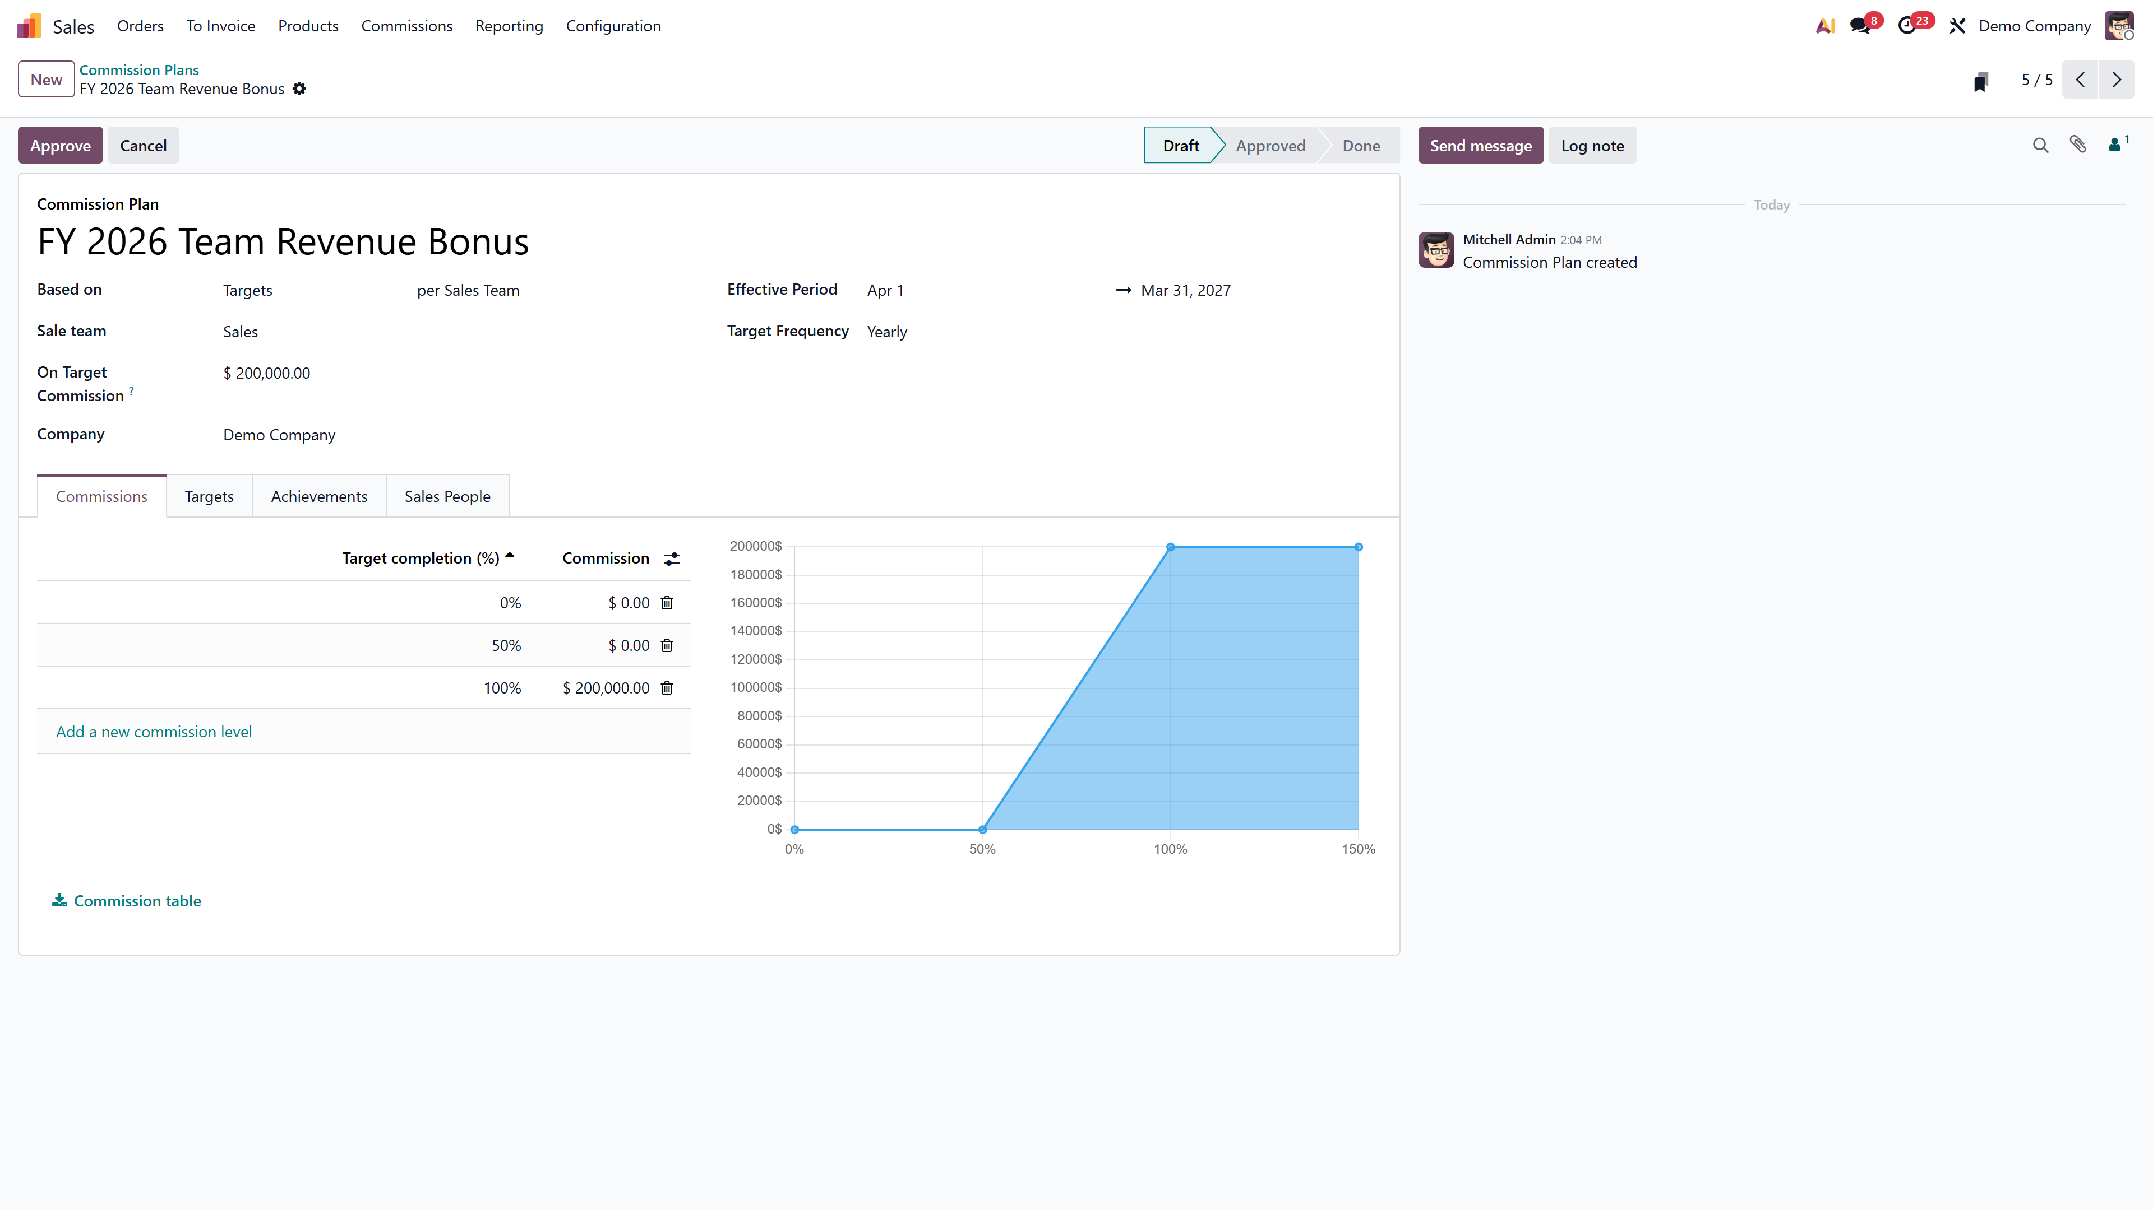
Team-based commission plan with Sales Team field

Side-by-Side Comparison

Aspect | Individual (Salesperson) | Team (Sales Team)
Who is evaluated | Each person independently | Team as a collective unit
Target applies to | Each salesperson’s own performance | Combined team performance
Sales Team field | Not required | Mandatory
Achievement tracking | Per salesperson’s invoices/orders | Sum of all team members’ invoices/orders
Commission payout | Based on individual % of target | Based on team % of target
Best for | Independent reps, territory-based selling | Collaborative deals, branch-level KPIs
Mid-quarter hire handling | Custom From date per person | Custom From date per person
Reporting | Per-person commission data | Per-team data with member breakdown

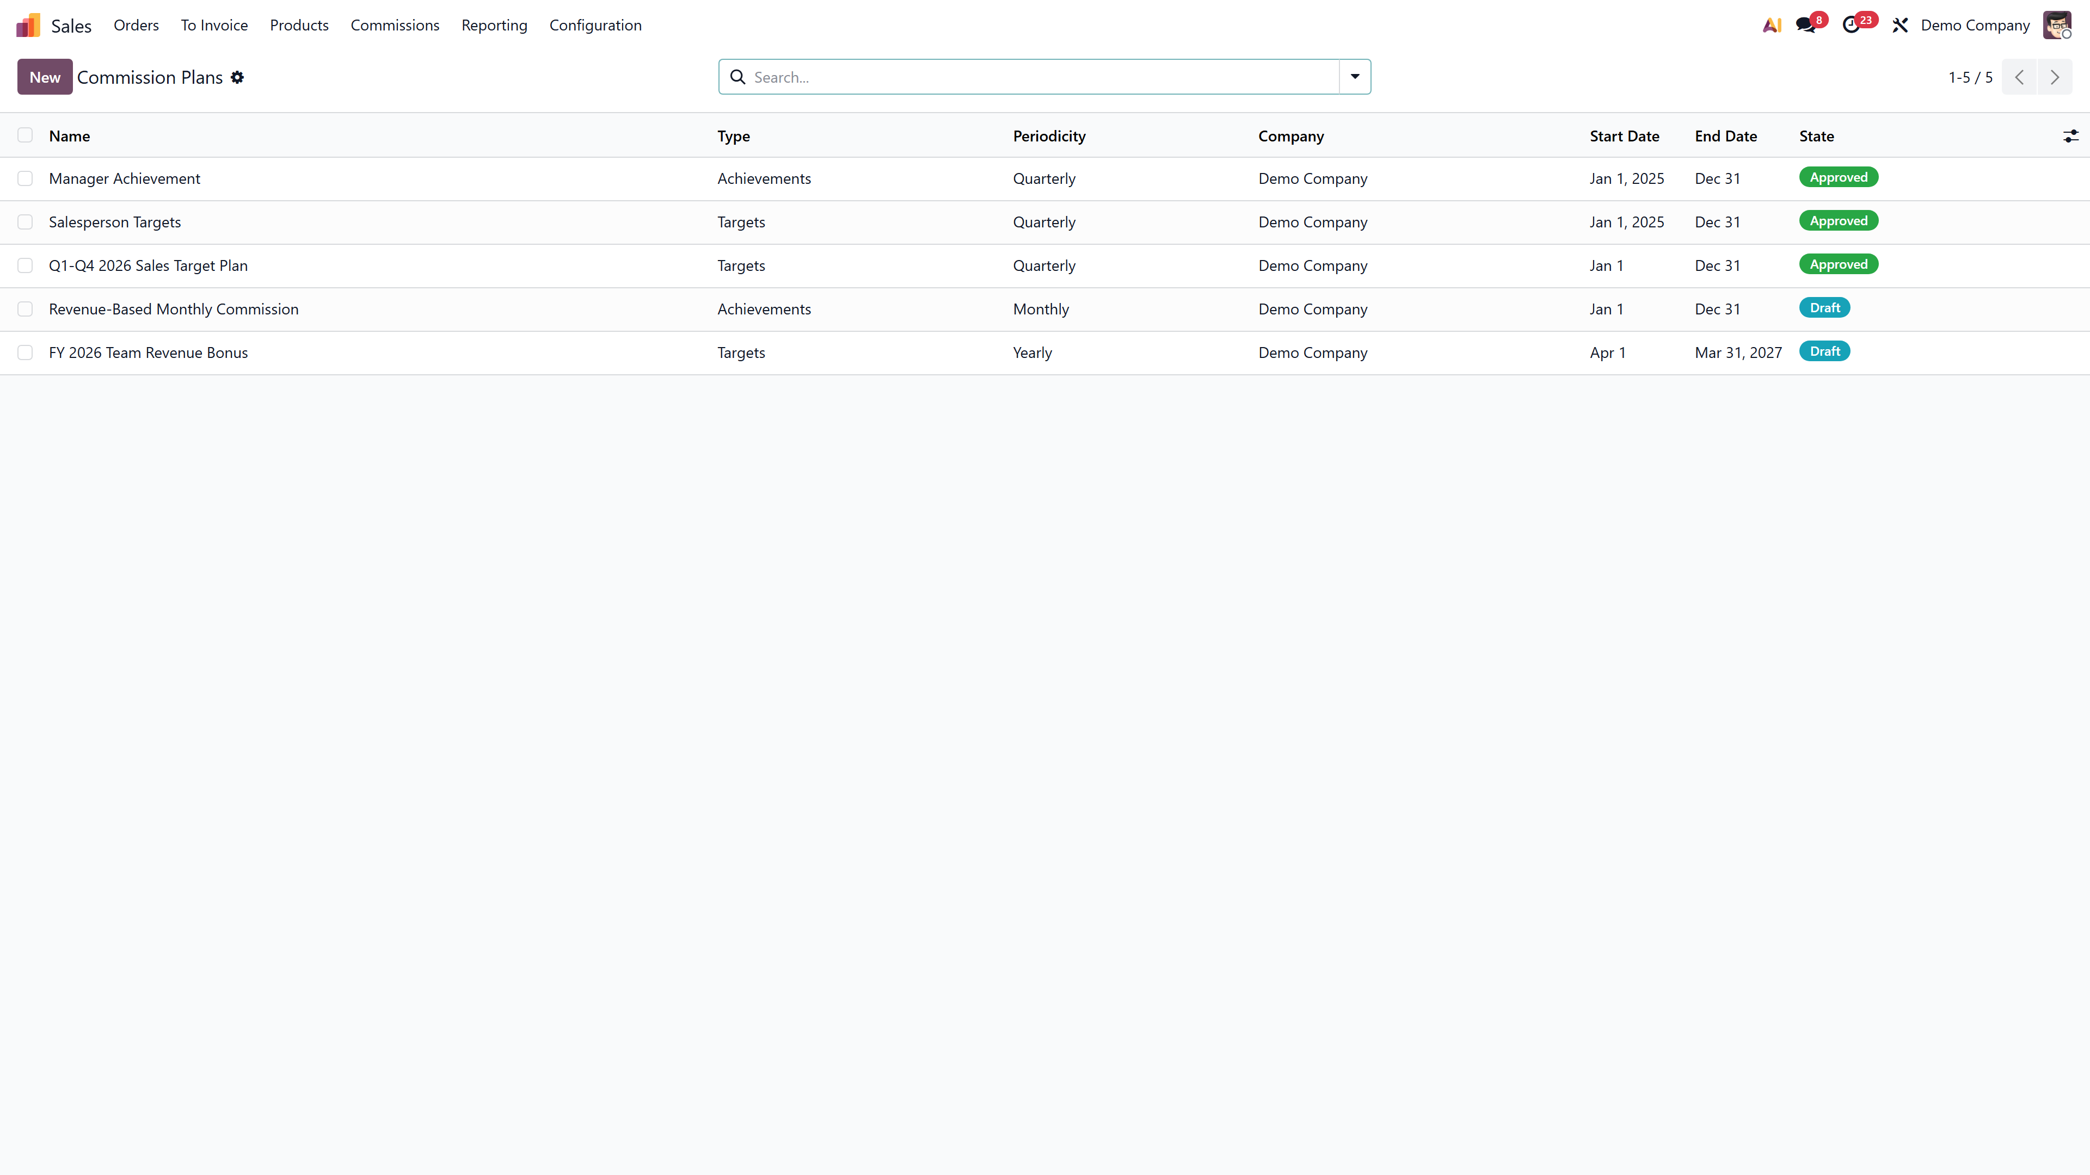
Commission Plans list showing individual and team plans side by side

Running Both Plans Together
Yes, you can run both simultaneously. A salesperson can be assigned to:
- An individual plan tracking their personal quarterly targets
- A team plan tracking the overall branch revenue target
Both plans calculate independently. Commission from each plan is tracked separately in the Commissions report. This lets you create layered incentive structures:
- Base commission: 2% on all personal invoiced amounts (individual achievement plan)
- Team bonus: ₹25,000 if the “West Region” team hits ₹50,00,000 quarterly (team target plan)

Pro Tip: Use distinct plan names that clearly label the type — e.g., “FY26 Individual Sales Target” and “FY26 West Region Team Bonus” — for cleaner reporting and payslip review.

Achievement Metrics That Work with Each
Both individual and team plans support the same achievement types:

Achievement Type | What It Measures | Available For
Amount Invoiced | Revenue from confirmed invoices | Individual & Team
Amount Sold | Revenue from confirmed sales orders | Individual & Team
Quantity Invoiced | Number of units invoiced | Individual & Team
Quantity Sold | Number of units in confirmed sales orders | Individual & Team
Margin | Profit margin (requires optional module) | Individual & Team
MRR | Monthly Recurring Revenue (requires subscription) | Individual & Team

Category Filtering
Both plan types allow filtering by Product Category. If you sell electronics and furniture but only want to commission on electronics, set the category to “Electronics” on the achievement line.

Adjustments and Manual Corrections
Real business is messy. A customer returns goods. A salesperson transfers mid-quarter. A credit note cancels part of a large order.
Odoo handles these through the Adjustments feature:
- Achieved amount — the manual adjustment value
- Add User — the salesperson whose commission increases
- Reduce User — optionally reduce another salesperson’s commission
- Date — when the adjustment applies
- Note — description for audit trail
Adjustments work identically for both individual and team plans.
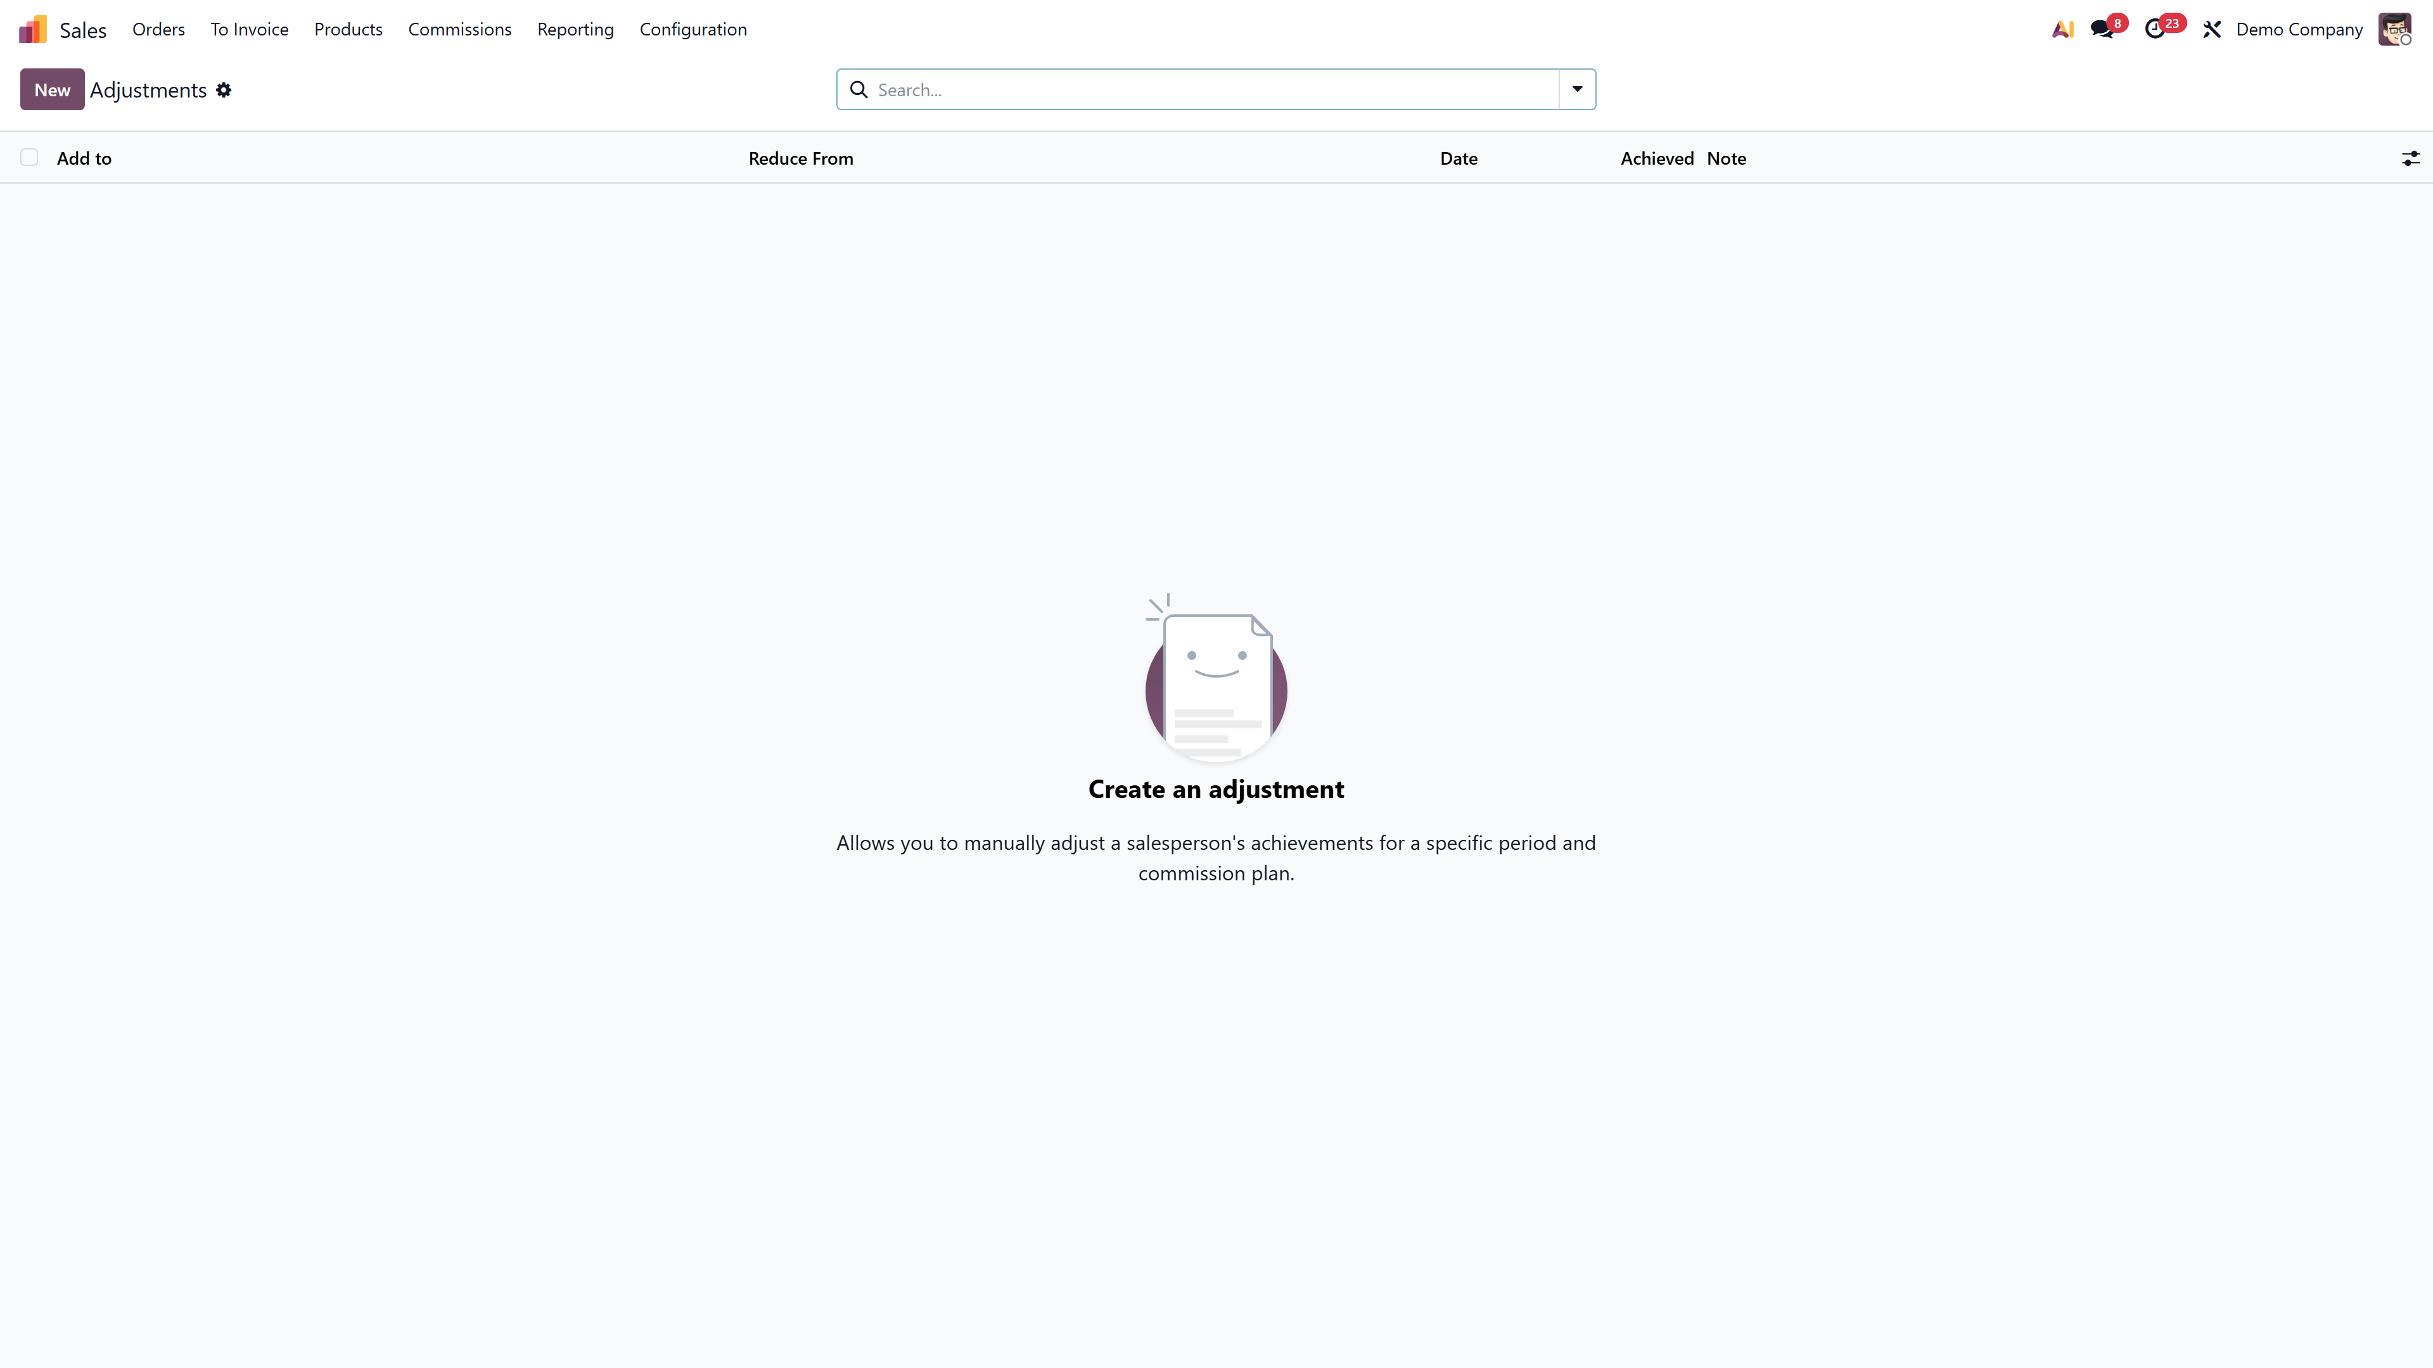
Adjustments view with Add User, Reduce User, and Note fields

Payroll Integration for Both
When HR Payroll is installed alongside Commissions, each plan gets a Payslip input field. This links the plan to a payroll input type (e.g., “Sales Commission”), so calculated commissions automatically appear as a line item in employee payslips.
Flow: Sales tracked → Commission calculated → Linked to payslip input type → Payslip generated → Commission paid as salary component
This works for both individual and team plans. For team plans, each member’s share appears in their individual payslip.

Reporting and Dashboards
Sales → Reporting → Commissions provides pivot and graph views showing:
- Commission per salesperson or team
- Period-wise trends
- Achievement percentages
- Payout totals
Filter by plan, salesperson, date range, or team. Export to Excel for further analysis.
The My Commissions view gives each salesperson a self-service dashboard showing their own earnings across all plans — both individual and team — without seeing others’ data.
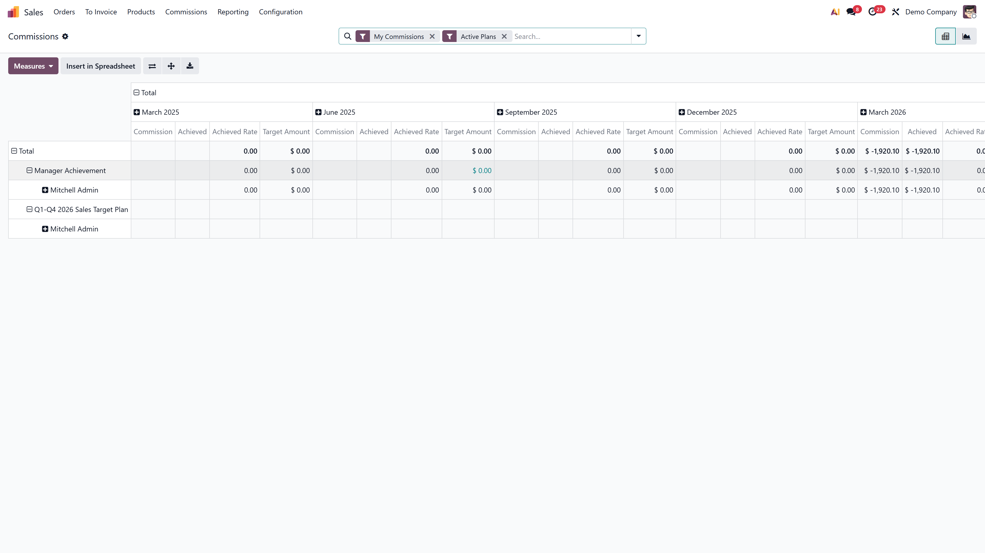
Commission reporting pivot view with salesperson-wise breakdown

Practical Setup Walkthrough: Indian Distribution Company
Scenario: ABC Distributors, Kochi — 12 sales executives across 3 regions (South, West, North), each region has a team lead.

Individual Plan — “FY 2026 Quarterly Sales Incentive”
- Type: Targets, per Salesperson
- Periodicity: Quarterly
- Effective Period: April 2026 – March 2027
- On Target Commission: ₹25,000
- Achievement: Amount Invoiced, Rate 1.0, All products
- Levels: 0%→₹0 | 50%→₹8,000 | 100%→₹25,000 | 150%→₹37,500 | 200%→₹50,000
- Sales People: All 12 executives added
- State: Approved

Team Plan — “FY 2026 Regional Team Bonus”
- Type: Targets, per Sales Team
- Sales Team: “South Region” (repeat for West and North)
- Periodicity: Quarterly
- On Target Commission: ₹50,000
- Achievement: Amount Invoiced, Rate 1.0, All products
- Levels: 0%→₹0 | 75%→₹25,000 | 100%→₹50,000 | 125%→₹65,000
- Sales People: 4 team members (South Region)
- State: Approved

What Happens
- Each salesperson earns commission based on their individual performance (individual plan)
- Additionally, if their region hits the team target, each member earns the team bonus
- Both commissions show in their payslips as separate line items
- Management sees all data in Sales → Reporting → Commissions

Frequently Asked Questions
1. Can a salesperson be in both an individual and a team plan?
Yes. Plans are independent. A salesperson can have multiple active plans — one individual, one team, or even multiple of each. Commission from each plan is tracked and paid separately.
2. If a team member leaves mid-quarter, does the team target change?
The target doesn’t automatically change, but you can use the custom To date in the Sales People tab to stop tracking the departing member. Use Adjustments for any corrections needed.
3. Can different team members have different commission percentages in a team plan?
Not directly in the plan. Team plans calculate a single payout based on team achievement. If you need differentiated payouts, create separate individual plans with different OTC amounts for each member, in addition to the team plan.
4. How does the system decide which salesperson gets credit for a sale?
Odoo uses the Salesperson field on the invoice or sales order. Ensure your sales team correctly assigns this field — it’s the single source of truth for commission attribution.
5. Can I set different targets per quarter for a team plan?
Yes. The Targets tab allows you to edit each auto-generated period’s target amount individually. Set Q1 lower during lean months and Q4 higher during peak season.

Need help designing commission structures for your sales organization? Talk to the Odoo experts at Infintor Solutions — we’ll set it up, test it, and make sure your team is motivated from day one.

